INDIAN EDUCATION PUBLIC SCHOOL
HALF-YEARLY EXAMINATION 2026–27
CLASS X (CBSE)
Mathematics

M.M. 80

General Instructions:
Read the following instructions very carefully and strictly follow them :
- This question paper contains 38 questions. All questions are compulsory .
- This question paper is divided into 5 sections – A,B,C,D and E.
- In Section A- Question numbers 1 to 18 are multiple choice questions(MCQ) and question number 19-20 are Assertion-Reason based questions of 1 mark each.
- In Section B- Questions numbers 21 to 25 are very short answer(VSA) type questions, carrying 2 marks each.
- In Section C- Question numbers 26 to 31 are short answer(SA) type questions, carrying,3 marks each.
- In Section D- Question numbers 32 to 35 are long answer(LA) type questions carrying 5 marks each.
- In Section E- Question numbers 36 to 38 are case-study based questions carrying 4 marks each. Internal choice is provided in 2 marks question in each case- study.

SECTION A
(This Section contains 20 Multiple Choice Questions carrying 1 marks each)

1.
(a) 4 (b) 6
(c) 2 (d) 0
2. The largest 3-digit number is :
(a) 999 (b) 111
(c) 500 (d) 100
3. 2×1768×50 equals to :
(a) 17870 (b) 18900
(c) 17800 (d) None of these
4. 30 Thousand _____ 3 lakh ?
(a) < (b) >
(c) = (d)None of these
5.How many zeroes are there in one lakh :
(a) 3 (b) 5
(c) 6 (d) 4
6. Even Parity + Even Parity =
(a) Even (b) Odd
(c)Composite (d) None of these
7. What is the value of 2 × 17.68 × 50?
(a) 176.8 (b) 1768
(c)176.08 (d) 17.68
8. Find the value of 16 − (−12 + 10).
(a) 18 (b) 14
(c) 6 (d) 4
- What is 6/20 + 8/20?
(a) 7/10 (b) 14/20
(c) 3/5 (d) Both (a) and (c)
- Find the difference: 34.505 − 18.5.
(a)16.005 (b) 16.05
(c) 15.005 (d) None of these
- Simplify: 3x + 4x
(a) 7x (b) 28x
(c) 34x (d)None of these
- The value of 26×74 equals to……..
(a) 1924 (b) 2024
(c) 1111 (d) None of these
13. Simplify: 8x − (2x + 3)
(a) 6x + 3 (b) 6x − 3
(c)10x + 3 (d) 10x − 3
14. If one angle of a linear pair is 70°, the other angle is:
(a) 40° (b) 110°
(c) 80° (d) None of these
15. 1 kg is equal to:
(a) 10 g (b) 100 g
(c) 10000g (d) 1000 g
16. 65 grams is equal to:
(a) 0.65 kg (b) 0.065 kg
(c) 6.5 kg (d) 650 kg
17. A magic square is a square in which:
(a) All numbers are equal (b) Every row, column and diagonal has the same sum
(c) Only rows have the same sum (d) Only columns have the same sum
18. A triangle having all three sides equal is called:
(a)Scalene triangle (b) Isosceles triangle
(c)Right-angled triangle (d) Equilateral triangle

Directions : Question number 19 and 20 are Assertion and reason based questions. Select the correct option.
(a) Both Assertion (A) and Reason (R) are true, and (R) is the correct explanation of (A).
(b) Both (A) and (R) are true, but (R) is not the correct explanation of (A).
(c) (A) is true, but (R) is false.
(d) (A) is false, but (R) is true.

19. Assertion (A): Two supplementary angles can form a linear pair.
Reason (R): The sum of two supplementary angles is 180°.
20.Assertion (A): 1 kg = 1000 g.
Reason (R): To convert kilograms into grams, we multiply by 1000.

SECTION B

[ Question numbers 21 to 25 are Very Short Answer(VSA) type questions, carrying 2 marks each ]
- Calculate: 145×30 .
- Find:
14 − (−12 − 6).
- Add:
(3/10 + 3 4/10)
24.Find the difference:
- 0.05
25.Simplify :
3x + 9y − 7 + 4x + 11y − 6x + 17

26.Draw the figure of two parallel lines and perpendicular lines.
27.Find the area of rectangle whose length is 19 cm and breadth is 34 cm.

SECTION C

[Question numbers 26 to 31 are Short Answer(SA) type questions, carrying 3 marks each ]

26.Calculate the following:
(i) 12.5 × 40 × 8 × 25
(ii) 25.00 × 12
(iii) 72 × 125

27. Find the sum:
(i)5/10 + 7/10
(ii) 2 5/10 + 3 2/10
(iii) 6/20 + 8/20
OR
Solve : 4a+4a+6a+2a+6b+3b
28.Define
(i)Parity
(ii)Parallel lines
(iii)Linear Pair

OR
Create a magic square using the numbers 1-9.

29.Tinku weighted 35.75 kg in January and 34.50 kg in february. Has he gained or lost weight? How much is the change?
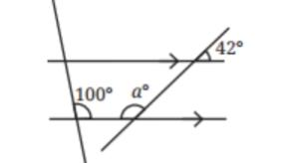
30.Find the angle ‘a’.

31.Solve:
- If a triangle has all sides equal with each side measuring ‘x’, find the perimeter.
- Make a magic square whose sum equals 60.

SECTION D

[Question numbers 32 to 35 are Long Answer(LA) type questions, carrying 5 marks each ]

32.Take a magic square and,
(a)Increase each number by 1.
(b) Double each number

OR

Find the angles :
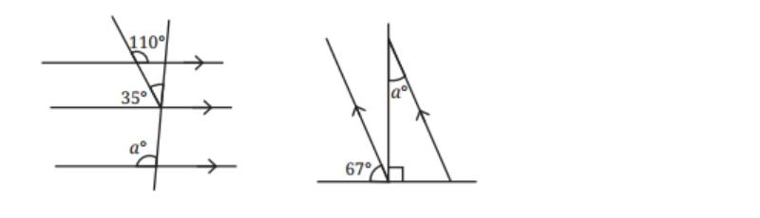

- Evaluate :
- 3÷ 7/9
- 4/3 ÷3/4
- 2/3÷3
OR
If ¼ kg of flours is used to make 12 rotis, how much flour is used to make 6 rotis?

- A car runs 16 km using 1 litre of petrol. How far will it go with ¾ litres of petrol?
OR
Which is heavier : 12/15 of 500 grams or 2/20 of 460 grams.
- Write the following fractions in decimal forms :
- 6/4
- 1/5
- 4/5

OR
Simplify :
- 8x-(2x-3) + 12
- 23+4(6m-3n)-8n-3m-18

SECTION E

[Question numbers 36 to 38 are Case Study Based Questions, carrying 4 marks each]
36. A teacher gives a group of students a 3 × 3 magic square. The students are asked to arrange the numbers from 1 to 9 so that the sum of every row, every column and both diagonals is the same.

8 1 6
3 5 7
4 9 2

Based on the above information, answer the following questions.
(i) Find the sum of the first row.
(ii) Find the sum of the second column.
(iii) Find the sum of the main diagonal.
(iv) What is the magic sum of the square?

37. A school canteen had 20 kg of rice. On Monday, 5.5 kg of rice was used. On Tuesday, 4.25 kg was used. The remaining rice was kept for Wednesday.
Based on the above information, answer the following questions.
(i) How much rice was used on Monday and Tuesday altogether?
(ii) How much rice was left after Tuesday?
(iii) Write 5.5 kg as a fraction.
(iv) Write 4.25 kg as a fraction.

